Novel Methods (Type Your Title Here – Times New Roman 14pt Bold)

Somchai A. Author1 (underline presenting author) and Somying Q. Author-Two2*

1(Italics, 8pt) Thailand University, Anytown, 55555 (Country)

2Fundamental Research Laboratory, Anytown, 44444-2222 (Country)

*somchai.a@thaiuniversity.ac.th (corresponding author designated with a star)

1. Introduction

Please provide here the introduction to your work. It can be as long as you wish but please be careful that all the information will have to be within 1 page of this template. In addition, this introduction can include the motivation, rationale, objective of the study, and scope of study.

2. Methodology

This section explains the “Experimental” or “Computational” details of your work. For experimental detail, a brief description of chemicals and tools should be provided, along with descriptions of experimental protocols, characterizations and methods to analyze the data. For theoretical or computational studies, related software packages, theory, basis sets, data analysis tools, or any methodology that seems fit to the study should be provided.

3. Results and Discussion

This section contains a description of key results along with discussion of related conclusions, and mechanism. For figures and tables, they should remain within the boundaries of one column of text. The font sizes less than 11 in Times New Roman are to be avoid, In the figures and tables, they should be numbered consecutively with captions given below figures and name of Table above the table. Text within the figure should not be sized less than 8pt font. It is best to use conventional formats for artwork (*.tif, *.jpeg, *.gif etc) but it is advised to create a *.pdf file.

**Table 1. Bulk Composition of Catalyst XYZ**

|  |  |  |  |  |
| --- | --- | --- | --- | --- |
| **Catalyst** | **%C** | **%N** | **%Ni** | **N / Ni** |
| XYZ/Al­2O3 | 19.8 | 15.2 | 20.7 | 2.41 |
| XYZ | 4.3 | 10.2 | 26.4 | 2.01 |

After presentation of data, it is common to describe it and the relevance to the objective of study.

4. Conclusion

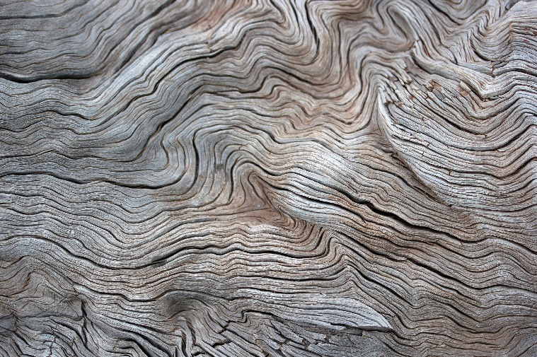

**Figure 1.** Reaction mechanism of catalyst XYZ. Note format of figures, text wrapping may be used.

References

1. Anonymous, *Computer and Catalyst Journal* 12, 23 (2021).
2. Einstein, A.B., Alex, A.H., and Glen, R. *Appl. Catal. A: General* 122, 289 (2000).

*Note that only references, which have been published in the open literature or are in press should be included in the References section. Use journal title abbreviations commonly employed by the Chemical Abstract Service.*

* Maximum of 10 pages